26 September 2024 postcard

Planes, trains, and automobiles!

Well, no actual planes today. We left our Bologna hotel at 8:40 am in a fleet of six chauffeured black limovans for the five-minute drive to the local train station, where we caught the 9:21 am to Venice (running only 15 minutes late).

Once in Venice, we found that the water was so high that our privately chartered water bus couldn't get under the bridges to reach its usually landing spot, so we had to take a short monorail ride to the dock where it was waiting for us. It then took us to our promised tours of Torcello and Burano islands while our local guide narrated the many historic buildings we motored past.

Afterward, back in Venice proper, the water bus couldn't take us to our hotel (it was too big to be allowed on the Grand Canal, so we transferred to a fleet of three water taxis, which delivered us to our hotel door. Our luggage was waiting in our rooms.

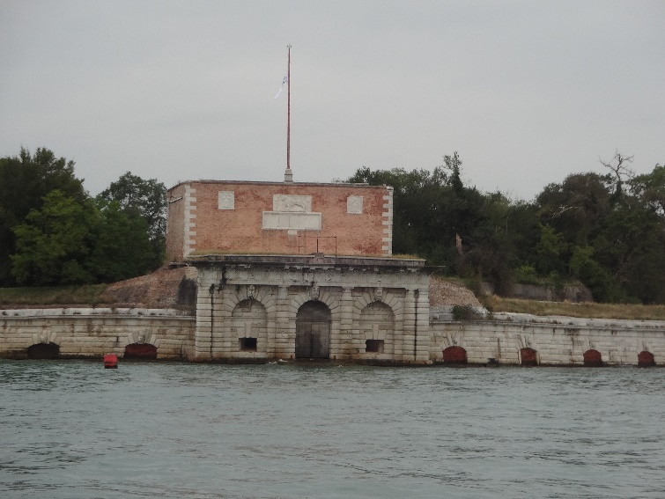But back to our tour of the outlying islands. On the way there, we passed this old fort, once part of the system defending the lagoon from marauding fleets.

Torcello Island, total population six (6!), is mostly park land. We strolled from the landing spot along the wooded banks of this little canal, past this unsafe-looking little bridge, until we came to our lunch restaurant (Osteria del Ponte di Diabola).

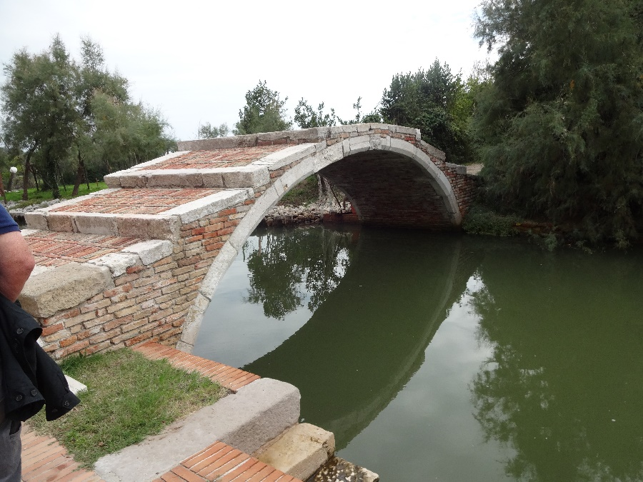

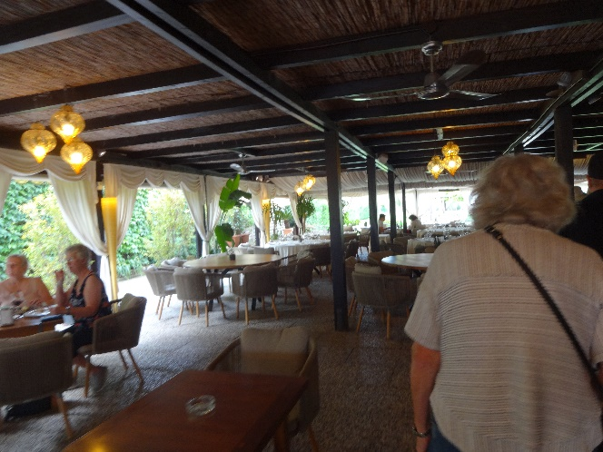There, we were seated in this beautiful outdoor dining room for a lovely three-course lunch.

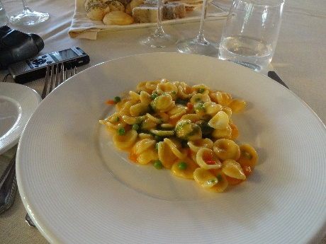The first course was orecchiette with peas, carrots, and red bell pepper.

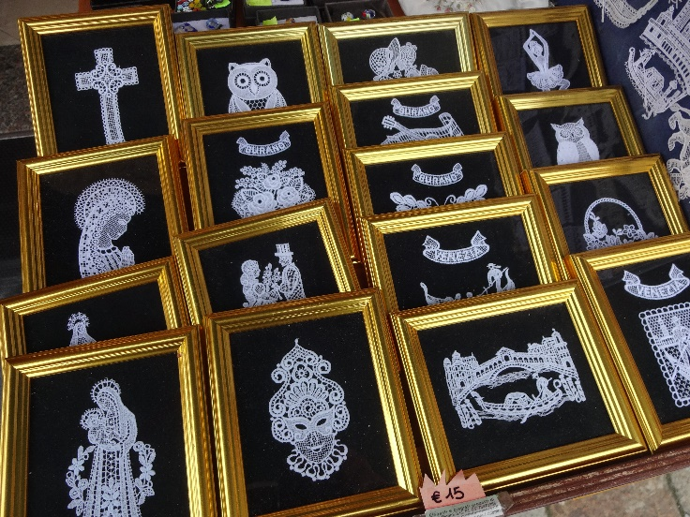

Then we moved on to Burano, famous for its needle lace, colorful houses, and yet another leaning tower.

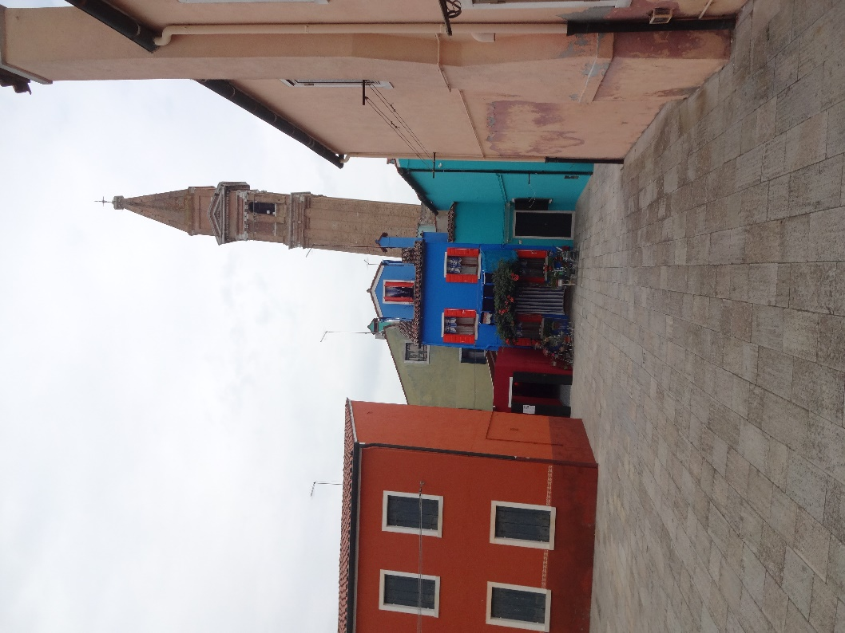.

Excellent supper at Antico Martini, where last year's Tauck farewell dinner was held.